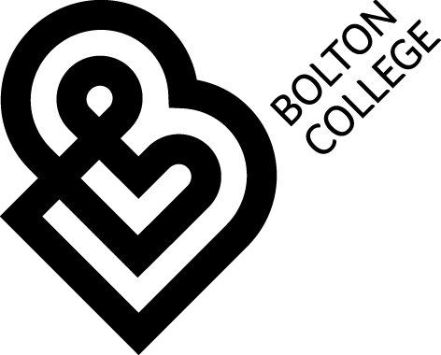 | Financial Support for Young People (16-18) at Bolton College 2018/2019
There are 4 types of financial support on offer to young people aged 16 to 18 (on or before 31/08/2018) at the College. Please read this information leaflet carefully to see if you qualify, what evidence you may need to show us to prove you qualify and, what you will receive if you do qualify.
Guaranteed Bursary:
You qualify for this type of bursary if:
- You are aged under 19 and In the care of the local authority or have recently left care or
- You are aged under 19 and receive Income Support/Universal Credit in your own right or
- You are aged under 19 and receive both ESA and PIP/ DLA in your own right.

Evidence needed would be a letter from your social worker explaining you are ‘looked after’ or have recently been ‘looked after’ and your award letters for all the benefits you receive (must be dated in the last 6 months). Bring in your bank details too so we can pay you directly into your bank account.

What would you get on a Guaranteed Bursary?
- £33 per week during term time paid into your bank account in arrears. Payment is based on full attendance at College.
- Costs of essential equipment (your tutor will tell you if there is essential equipment for your course and you can buy it, keep the receipt for us and we will refund the cost).
- A free lunch for each day you study in College.

Discretionary Bursary:
You can receive this type of Bursary if your family household income is no more than £20,000 per year and you have 90%+ attendance at College.

Evidence needed would be your parent/ carer’s latest Tax Credit Notice for 2018-19 and we will check your attendance using registers once you start your course.
What would you get on a Discretionary Bursary?
- Costs of essential equipment (your tutor will tell you if there is essential equipment for your course and you can buy it, keep the receipt for us and we will refund the cost).
- Help with travel costs if you travel more than 2.5km from your home to the College Campus where you are studying. (We use Google maps / AA Route finder to check distances).
- If you live in the Greater Manchester Area and are travelling to College by public transport we request that you purchase a 16-18 Get Me There Card and College will pay for your return journeys to College by paying money into your bank account in arrears.
- If you live outside the GM area College will contribute to your travel costs by agreeing with you the cost of your travel to College, and then paying money directly into your bank account in arrears.

Free College Meals:
You can receive a Free College Meal worth £2.41 for each day you are studying, if you are eligible for the Guaranteed Bursary or if your parent / carer receives one of the following income based benefits:
- Income Support
- Income Based Job Seeker’s Allowance
- Income Related Employment and Support Allowance
- Guaranteed Element of Pension Credit
- National Asylum Seeker’s Support
- Child Tax Credit (but not Working Tax Credit) on income less than £16,191 (as assessed by HMRC)
- Universal Credit with net earnings not exceeding the equivalent of £7,400 per year

Applying to the College for Financial Assistance:
The College Funds available to support students are limited and applying for these funds does not guarantee assistance.
- To apply for assistance please collect and complete in full a 2018-19 Application for Financial Support for Learners Aged 16-18 from Student Services at the Deane Road Campus.
- Return this completed application to Student Services with any evidence required as soon as possible in person (we do not keep the evidence but will scan this into our system and return this to you when you come to see us)
- Please note that when funds are exhausted applications will be refused. We deal with applications on a first come first served basis.
- If you are struggling with any part of the process of applying for assistance or the Get Me There Card, the Student Finance Team will be happy to help.
- You can contact the Student Finance Team on 01204 482191; 01204 482199; 01204 482183 and 01204 482192

Even if you don’t qualify for financial support we may still be able to help with your travel costs
If you don’t qualify for any of our bursaries and you live in the Greater Manchester area, the College will make a £10 contribution to cover the cost of your 16-18 Get Me There Card.

You will need to present your 16-18 Get Me There Card to staff in Student Services and they will be able to refund the £10 it cost to buy the card. You will need to pay for your own journeys to and from College throughout the year.

Please bring your bank details so we can refund the cost of the card directly into your bank account.

How to buy a 16-18 Get Me There Card:
- To purchase your 16-18 Get Me There Card go to http://www.getmethere.com/
- Check out the box called Are you 16-18?
- Check that the list of bus companies who use the 16-18 Get Me There Card will be the ones who you will use to get you to and from College each day
- Click on Apply for your card now
- This will take you through to a page called Create your get me there account now
- Click on Create Your Account Now
- Follow the instructions to create your account and purchase your 16-18 Get Me There Card
- With your 16-18 Get Me There Card you get 50% off any bus Day Travel Card. This means that the journey will cost you or your parent/carer (or the College if you are eligible for the Discretionary Bursary) £2.80 for each day you travel to and from College!

